In Canvas, under Modules please click on class_data.zip. Once you are on that page then click on Download class_data.zip. You will see the window below. Please “Save File” and press ok.

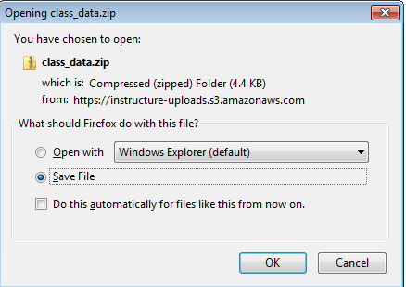

The file will be saved in your Downloads folder.

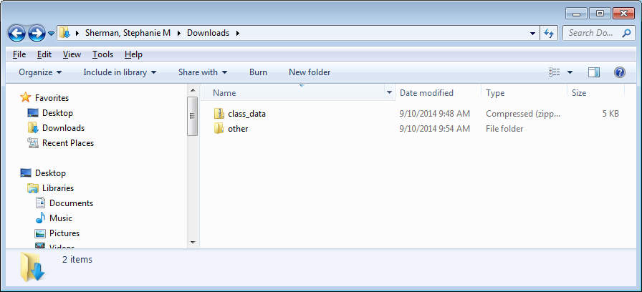

Go into the class_data folder and then copy the class_data folder to move data to appropriate location. You may get a warning but it should still work.

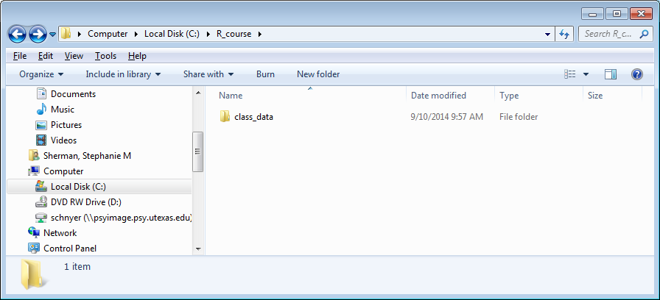

Go in the folder. Right click on the file you want to import and then click on “Properties”

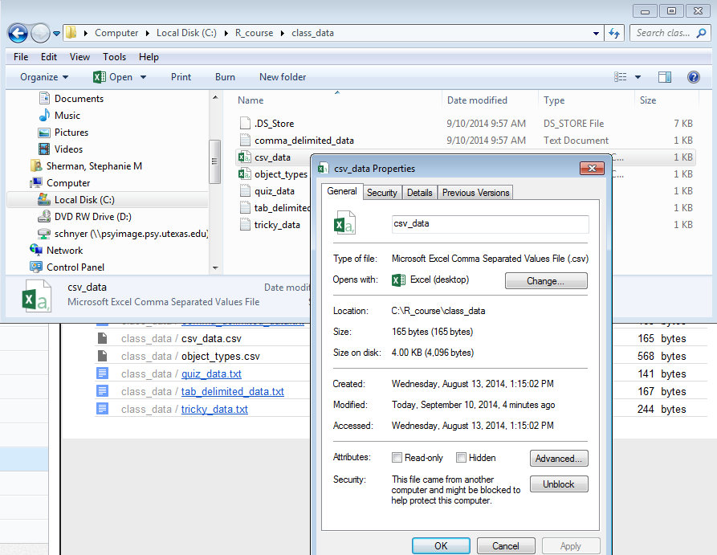

The “Location” is the path. When you put the path into R do not forget to change the \ to / and add the file name with the extension. The path for this example would be "C:/R_course/class_data/csv_data.csv"